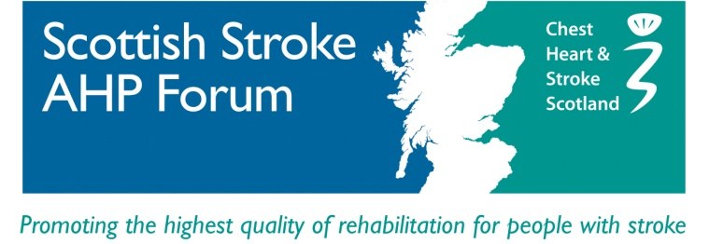

GUIDELINES FOR SCOTTISH STROKE AHP FORUM

PRACTICE DEVELOPMENT AWARDS

The SSAHPF accepts applications for funding for AHP’s to attend and/or organise meetings, courses and training days, or to undertake study visits to recognised centres of excellence.

Applicants must be living and working in Scotland and be a member of the SSAHPF

Priority will be given to those living and working in rural areas where there are likely to be significantly higher travelling and subsistence costs involved in such visits.

Applicants must approach their employer/centre of education for funding before approaching the SSAHPF, and any pledged funding noted on application. If employer funding is not available, please state reason. Joint applications (i.e. more than one person or more than one study event listed on the application form) will not be accepted.

Applications will be considered only on the relevant application form. Applications will go before the members of the SSAHPF committee and a decision made at the next quarterly committee meeting. It is a stipulation of funding that a short report be submitted to the SSAHPF immediately after returning from travel, or on completion of study. If application is successful, monies will be refunded on submission of receipts.

For further information, contact Jacqui Morris: email j.y.morris@dundee.ac.uk

Practice Development Awards
Application form

Name:
Address for correspondence:
Contact telephone:
Email:
Degrees/qualifications:
Present employer and place of appointment:
Position:
Nature of activity for which funding sought:
(e.g.. course, study, visit, etc.)
Details of location of course/visit:
Date(s):
Full break-down of costs involved:
Details of other funding received/applied for, including details of refused requests and reason why employer funding not available
Amount requested from SSAHPF:
Head of Department approval (if applicable):
Date of application:
Date received by SSAHPF:

Practice Development Awards
Application form continued.

Name:

Why have you chosen this particular course/study visit/other activity?

How will this activity enhance directly the quality of patient care for people affected by stroke, within your normal working environment?
How do you plan to share/ disseminate this learning or activity?

