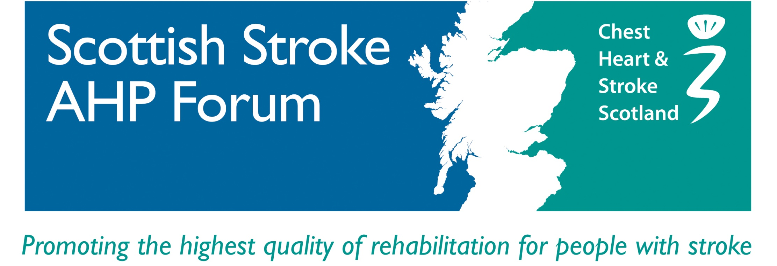

**Scottish Stroke AHP Forum**

**6th Conference**

**University of Dundee**

**Wednesday 13th June 2018**

**Speaker Biographies**

**Dr Jacqui Morris**

Reader in Rehabilitation Research, School of Nursing and Health Science, University of Dundee

Honorary AHP Consultant in NHS Tayside

**________________________________________________________________**

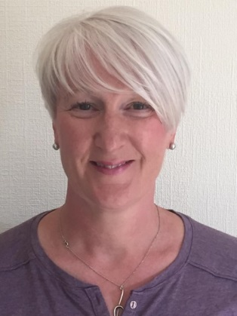

Dr Jacqui Morris is a physiotherapist and Reader in Rehabilitation Research in the School of Nursing and Health Science at the University of Dundee, and an Honorary AHP Consultant in NHS Tayside. Her main research interest is stroke rehabilitation and recovery, and she is particularly interested in upper limb recovery, promoting physical activity after stroke and implementation of evidence into AHP clinical practice. Methodologically, her skills are in complex intervention development and randomized controlled trials, qualitative methods and systematic reviews. She sits on the Chief Scientist Office Health Protection and Services Research Committee, is chair of the Scottish Stroke Allied Health Professions Forum and is a council member for the Society for Rehabilitation Research. She has held several government funded grants and publishes in peer reviewed journals. Her work has influenced policy and clinical guidelines for stroke rehabilitation.

**Dr David J Clarke**

Associate Professor in Stroke Care, Academic Unit of Elderly Care and Rehabilitation, Institute of Health Sciences University of Leeds

**________________________________________________________________**

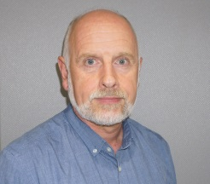

David works within the Academic Unit of Elderly Care and Rehabilitation, which is part of the Institute of Health Sciences at the University of Leeds. He is an experienced qualitative researcher working primarily in the area of stroke rehabilitation. David has a keen interest in how health professionals in stroke services understand and manage their work. He was Chief Investigator for the NIHR funded ReAcT study which examined factors influencing therapy provision to meet clinical guideline recommendations in eight stroke units. Currently, David is lead for the Yorkshire region for the NIHR Health Services and Delivery funded CREATE study which is using co-production methods to enable patients, carers and health professionals to collaborate in the design and implementation of interventions to increase activity for inpatient stroke survivors. He is also qualitative and process evaluation studies lead on two NIHR funded programmes of research. The RECREATE study is investigating ways to reduce sedentary behaviour after stroke (led by Prof Anne Forster) and the HERO study is a large individually randomised controlled of a home based exercise programme for older adults with frailty (led by Dr Andy Clegg). Previously, David led the process evaluation team for the Training Caregivers after Stroke (TRACS) trial, and has conducted research examining the work of nurses in stroke rehabilitation teams.

**Fran Brander**

Consultant Physiotherapist, National Hospital for Neurology and Neurosurgery

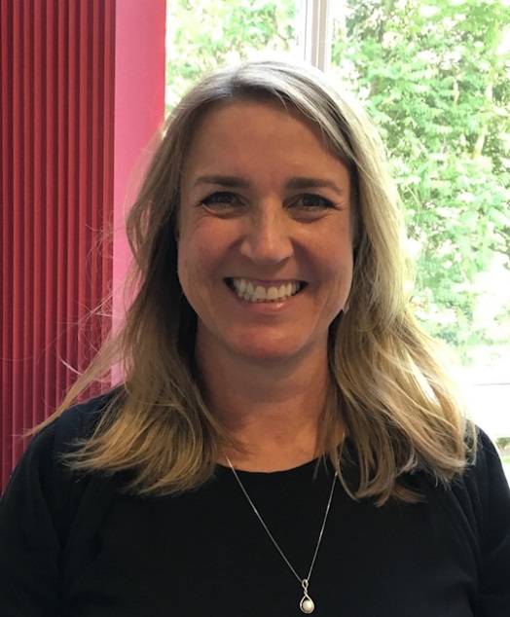

Fran Brander is a Consultant Physiotherapist in Stroke and Rehabilitation at NHNN (MSc, Grad. Dip. Phys., MCSP). Since graduating, she has primarily worked within the field of neurosciences at Regional Specialist Centres. Fran has worked at The National Hospital for Neurology and Neurosurgery since 2008 and is the lead Physiotherapist for the Hyper-Acute Stroke Unit (HASU), Acute Brain Injury Unit (ABIU) and Neuro-Rehabilitation Services including the Level 1 Neuro-rehabilitation Unit and Intensive Upper Limb Service. Fran has a strong commitment to evidence based practice, she is actively involved in teaching and has co-led various external study days. She completed her MSc in Advanced Neurophysiotherapy at UCL in 2004. Her specialist interests include Neurological, Stroke and Upper Limb Rehabilitation.

**Kate Kelly**

Consultant Occupational Therapist, National Hospital for Neurology and Neurosurgery

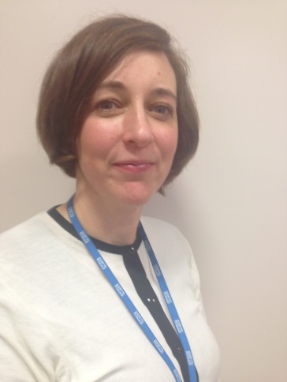

Kate Kelly is a Consultant Occupational Therapist (MSc, BSc (hons), BAOT). Since graduating, Kate has primarily been working with people with complex neurological impairments. Kate has been working at The National Hospital for Neurology and Neurosurgery since 2004 as the Consultant occupational therapist and is lead Occupational therapist for hyper-acute stroke unit, acute brain injury unit and neuro- rehabilitation services including intensive upper limb service. Kate is actively involved in teaching and has co-led various external study days. She completed her MSc in Advanced Occupational Therapy in 2012. Kate has a strong commitment to evidence based practice. Her specialist areas include neuro-rehabilitation, stroke rehabilitation, upper limb rehabilitation and vocational rehabilitation.

**Steven Boyle**

Strokeness

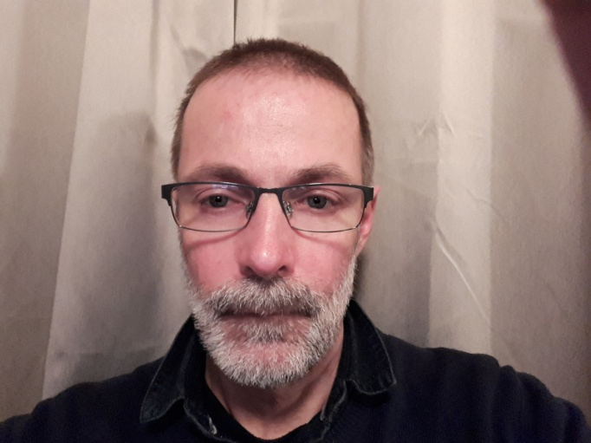

I am 55 years old living in the North East Highlands, I live with my wife and grandson, my wife and I have been raising our grandson for the past five years, after an abusive start in life, he is now 8 years old.

I had always lived an active life, an outdoor type you might say. I travelled lots, studied meditation, travelled to the Far East to find a meditation teacher, I also studied Chinese Yoga and Martial Arts, all of which I taught. In 2009 I graduated as a Hypnotherapist with counselling skills which I pursued as a career and enjoyed immensely.

In 2015 tragedy struck when on the 7th of January I had a stroke, followed by another stroke on the 7th of February exactly one month apart. From that point my life changed, initially I was in denial about what had happened, I was very confused and disorientated, so wasn’t really putting the pieces together in a coordinated way.

I started my journey of rehabilitation which lasted about a year. Initially I had problems with speaking, walking, word finding etc… 3 years later I find myself in a much better position, but, still having problems with memory, speed of processing, divided attention and fatigue.

For 30 years I had been a musician, one of the things I grieved for most was the inability to play my guitar after about 2 years after my strokes the ability to start to play started to return, I got with the Strokeness Charity, which connected with Drake Music Scotland, a music charity that is for people who have some kind of disability, it was another turning point in my life and remained positive friends with my 2 musical mentors. I became intrigued by the production side of how music is pieced together remotely, meaning now musicians can record in two different places but can then be pieced together by using technology, which brings me to the next stage in my life.

After doing 2 really good interviews I have been accepted by the University of Highlands and Islands to study sound production which covers all the different aspects of producing a record from recording my own songs to the final Master copies, so onward and upwards, another chapter starts in my life.

## Sheena Borthwick

Service Lead Speech and Language Therapist for Adult Community and Rehabilitation Services in NHS Lothian

**________________________________________________________________**

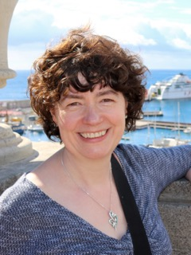

I am currently employed as the Service Lead Speech and Language Therapist for Adult Community and Rehabilitation Services in NHS Lothian. Within this role I maintain a clinical remit specialising in stroke and providing clinical leadership across the stroke pathway

I have over 25 years experience working as a speech and language therapist in hospital, community and education environments with the majority of my career focused on stroke and neurology.

I represent the Royal College of Speech and Language Therapists on The National Advisory Committee for Stroke in Scotland and have contributed to a number of national initiatives such as development of SIGN guidelines, Best Practice Statements, and STARS training modules.

My more recent interests include developing community services for stroke having moved my clinical sessions from the hospital stroke unit to rehabilitation at home. I am also interested in the role SLTs deliver within end of life care having contributed to the development of the STARS module on sensitive and effective conversations at the end of life after stroke and acted as the SLT advisor on CSO funded research project: Understanding the experiences and multi-dimensional needs of people with major stroke.

**Mrs. Katrina Brennan MBE**

Scottish Government Stroke Improvement Lead

Stroke MCN Manager NHS Lanarkshire

**________________________________________________________________**

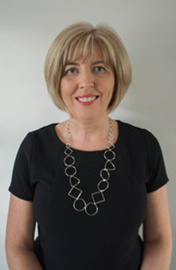

I have worked in my current role as Stroke MCN manager in NHS Lanarkshire since 2007 and have over the past 10 years combined that with the role of National Stroke Improvement Lead for the Scottish Government.

Prior to this joint post I have worked in Stroke Care for most of my nursing career. I trained at Glasgow Victoria Infirmary where I then went on to work in the care of the elderly department and set up the stroke unit. I then became the charge nurse in the stroke unit where I worked until 2001. I came to NHS Lanarkshire and took up the post of Stroke Liaison Nurse and in 2004 we increased the team of stroke nurses to six nurses in partnership with CHSS and I became the lead nurse for that team. I was involved in the development of the Stroke MCN in Lanarkshire and in 2007 became the MCN manager. In this role I manage both the stroke liaison nurses and therapists who provide our specialist longer term support to patients post stoke.

I am a member of the National Advisory Committee for Stroke and Chair the NACS/MCN Managers forum as well as being a member of the Scottish Stroke Care Audit steering group.

In 2017 I was honoured with an MBE for my services to stroke care in Scotland. I am passionate about making the care of Stroke patients in Scotland the best it can be and my current role allows me to fulfil that vision working closely with the stroke community in Scotland.

**Barbara Dalgetty**

Head of Rehabilitation Support at Chest Heart and Stroke Scotland (CHSS)

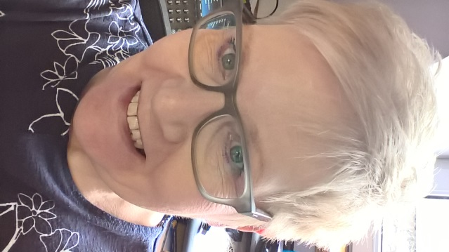

Barbara started her career with CHSS in 1997 as the volunteer stroke service (VSS) coordinator in Moray. Barbara has a strong connection with the charities conditions from her experiences as a nurse and personally from family life.

Barbara progressed to Regional Manager for the North of Scotland and, with this change of role came a renewed focus for the VSS developing new skills and learning in communication support.

Two years ago as part of an organisational restructure Barbara was appointed to Head of Rehabilitation Support with a national remit to support people in the community with chest heart and stroke conditions.

Barbara has overall responsibility for staff, volunteers and all of the rehabilitation support services across Scotland. Barbara has responsibility for services planning, provision, innovation and quality. Current service provision is for those who have had a stroke with a strong focus upon those with communication difficulties. The service has a strong focus on self- management and is very much driven by what is important to those who use the service.

Barbara is a key member of the senior management team contributing to strategic, operational and governance discussions.